SWE20001 – Development Project 1: Tools and Practices

High Distinction Task <11.2HD>

Duy Phuong Nguyen (101204984H)

Lab: Friday 2:30pm

Tutor: Huai Liu

Team number: 3

Henry Tran 102075482

Edward Knight 102700043

Duy Phuong Nguyen 101204984

# An overview introduction and summary of the project and its achievements or outcomes, in particular during your involvement

1. Battleship project

This is an 8-week project and I was the team leader for week 3 and week 6. I have a chance to practice leadership by completing the project. The requirements are converting CB code to C# code, adding new features and fixing bugs. We finished the battleship project on time and learned all 4 Unit learning outcomes by practising the project.

1. Exercise club website – D/HD project

I am team member, developer of our group for D/HD project, so all the coding and the project are designed by me. I also help my team leader to splitting the task, managing changes in our project, applying four-unit learning outcomes in this project.

Our D/HD project is an exercise club website. We chose to develop our project on website platform because our group has knowledges in web application, how to create and design a website and creating unique functions for our project.

The project’s aim is helping people who want to get fit but does not know how to start. Our website has search bar function, member database, activities list so member can find gym mates. Our project is finished on time with all the functions working properly. The project is written by using HTML, JS, CSS, PHP and MySQL system. Me and my team leader done all the coding with a total of 3 iterations. Our group apply Scrum software development process to construct the product.

# Documented evidence

1. Battleship project:

I took the leadership role of this assignment in week 3 and week 6.

Week 3:

In week 3, we have to create a wiki page for the battleship project. This is the first week of online delivery course so being a team leader is quite a challenge for me.

As a leader, I split the tasks of this week to my team member and ask confirmation from them.

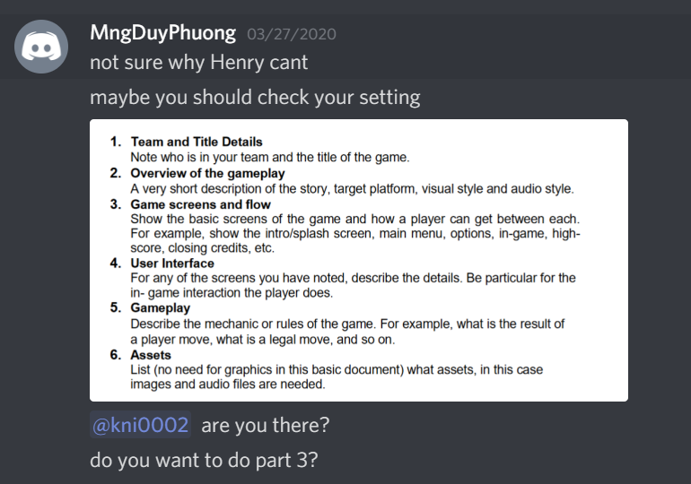

I created a project on GitHub and adding all the members

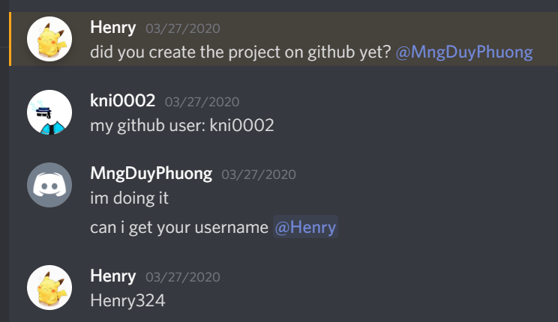

I created all the sub-pages for my team member so they can add their works, information to the project.

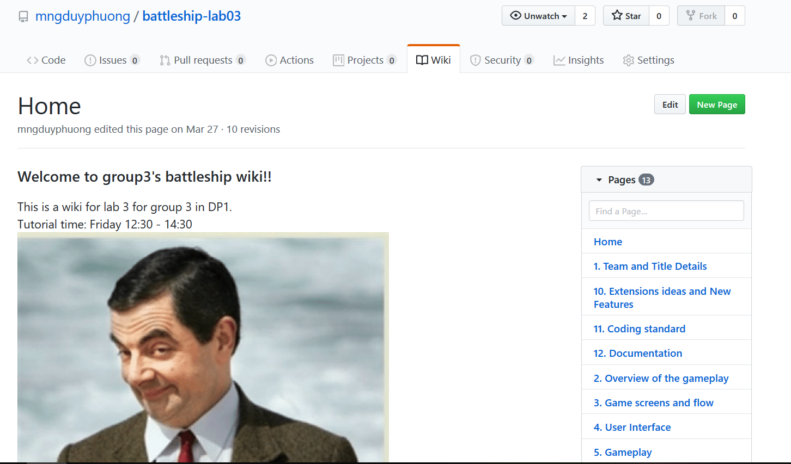

Week 6:

In this week, we applied DAD iteration process to the battleship project. As a leader for this week, I created a Google Drive doc so my members can contribute their work easily

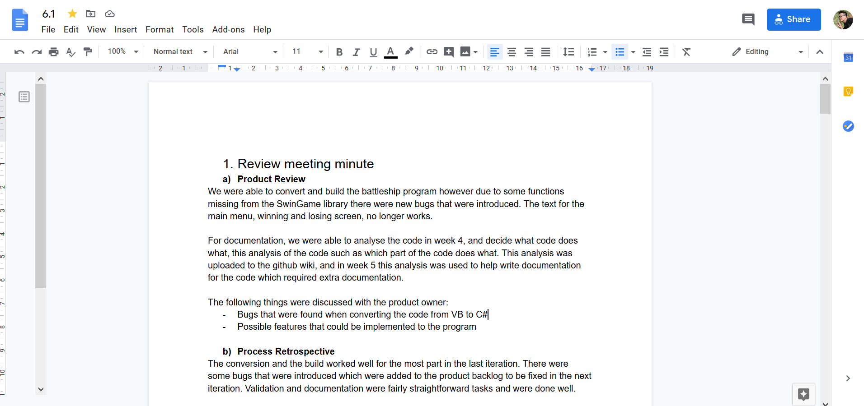

Posted the task of week 6 to discord channel and discussed about them with teammates

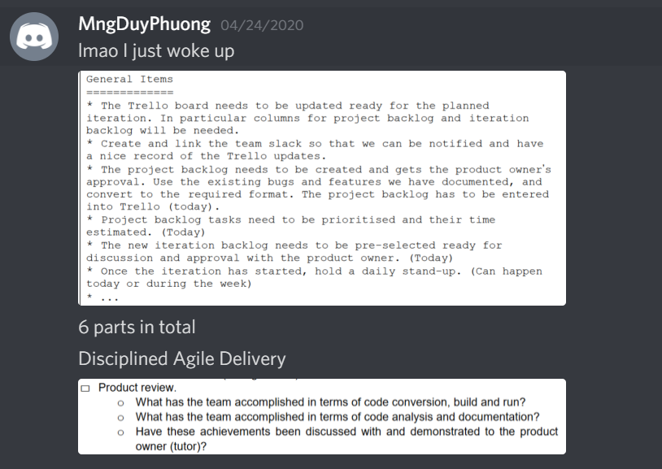

Splitting the tasks for member by using Iteration backlog

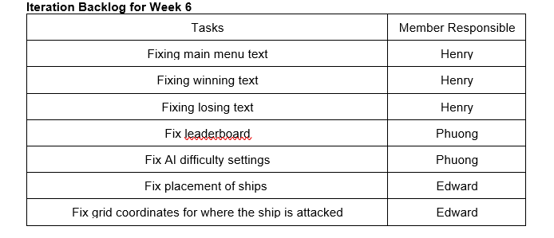

Planning and set deadline for tasks using Product backlog

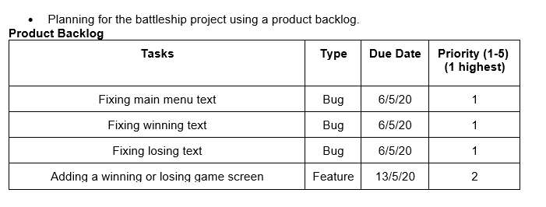

Meeting agenda for week 6 created by me

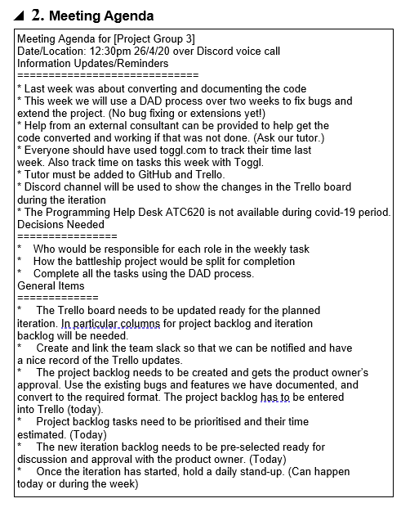

Meeting minutes with all the required information, envidence

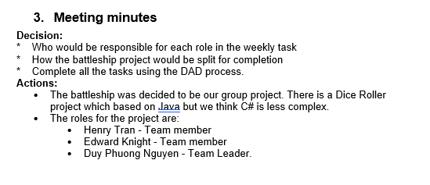

1. D/HD project:

As a developer of this project, my main role is coding and designing the website so I have a chance to practice leadership by guiding other members how engage the code, allocated task for members to code. I also help my team leader to managing the progress, applying Scrum development process to the project.

**Week 5:**

Reminded teammates about the deadline of vision document. My teammates are forgot about the D/HD project so I set the date and ask my friend want to join the project or I will join another group.

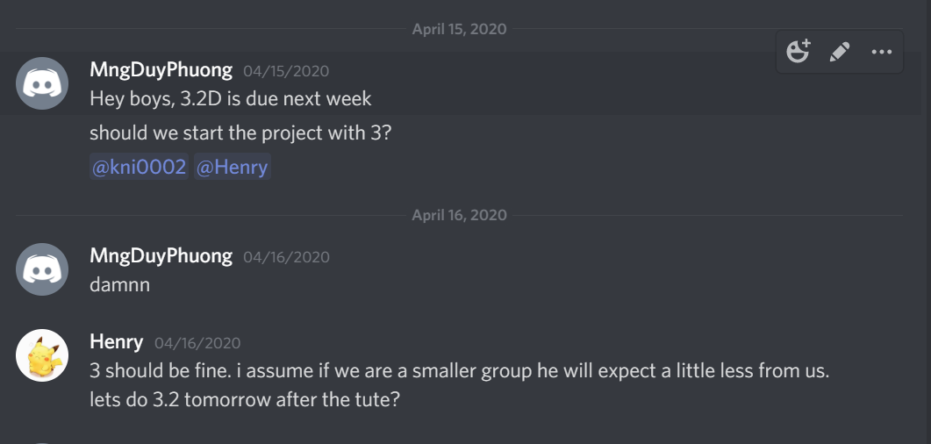

**Week 6:**

I did some research by myself and found out C# is a bit complex for our group since there are only 3 members. I suggested my group to swap from C# language to a Website which is easier, and we all have experiences in Web application

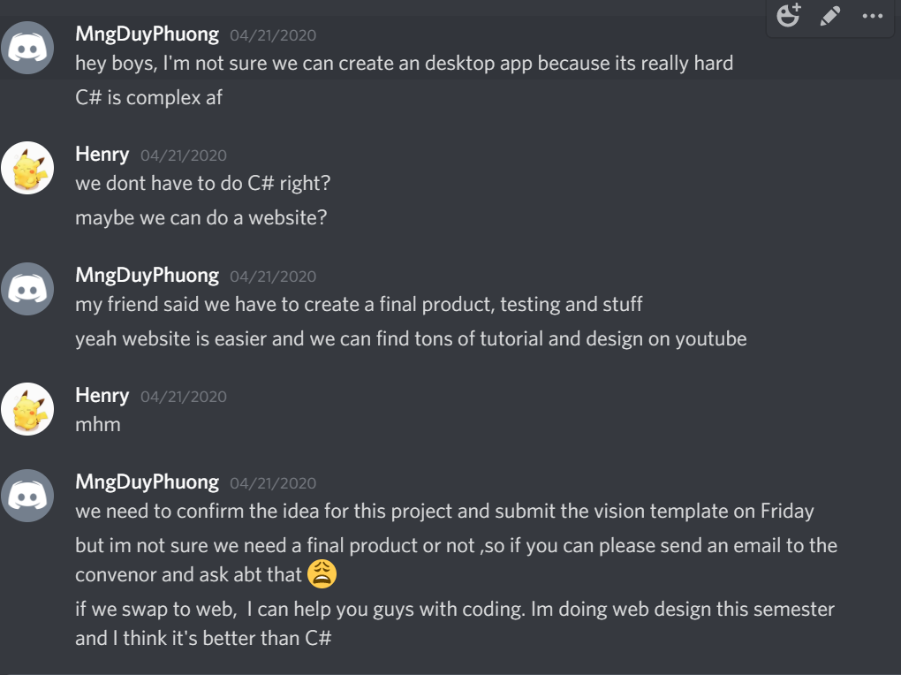

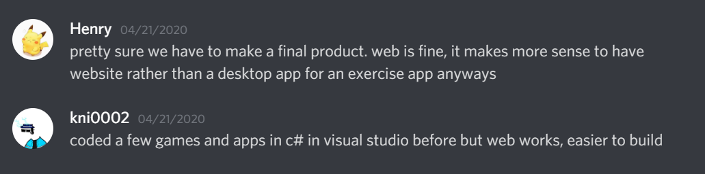

**Week 7:**

We start working on the project and ask our ‘Product owner’ which is Edward to complete the SRS so we know where to start. However, he didn’t finish his part so me and Henry (team leader) decide to outline the project.

I split the website into smaller part for me and Henry. For the first iteration, we need the skeleton of project which are the interface and template for the website. I have a test on this week, so Henry decided to help me design it.

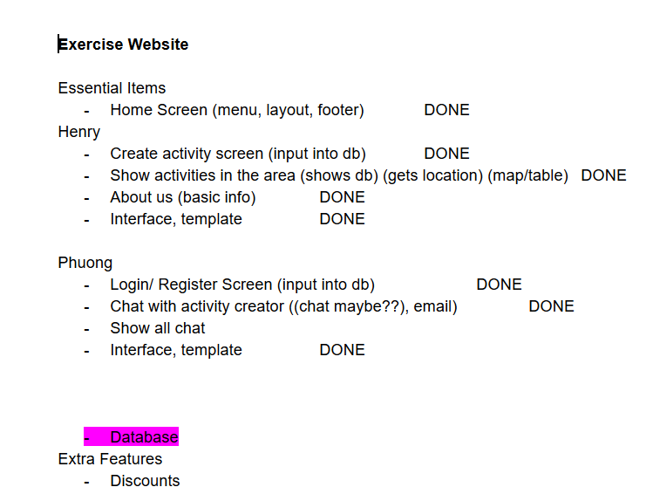

**Week 8:**

Henry sent his work on the project. 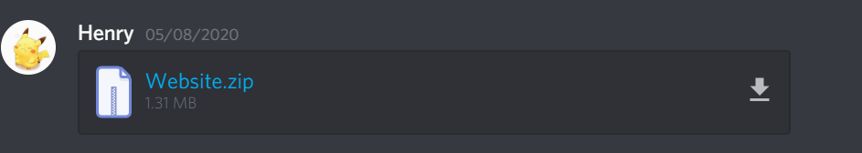

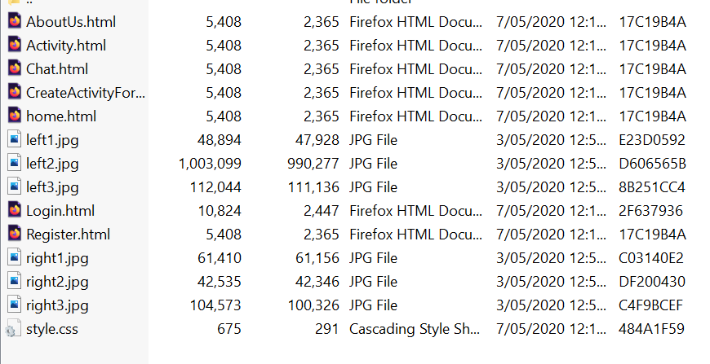

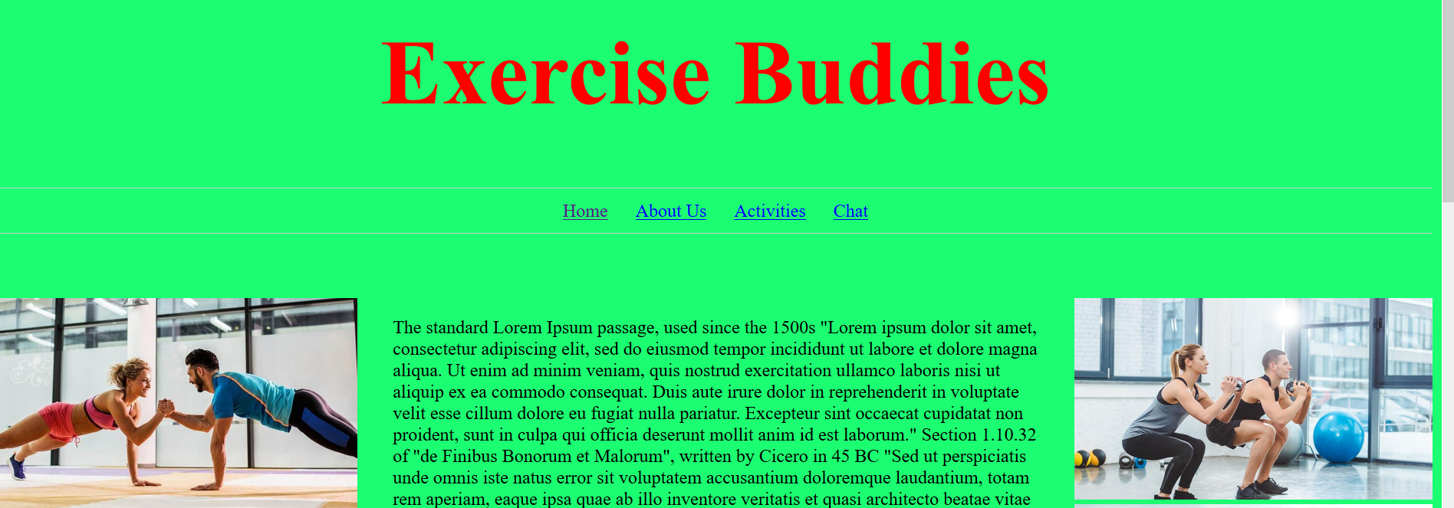

As the developer of the group, so my role is to lead the coding process. I think it can be better and I decide to re-design the website. I informed my team leader so he knows the situation and can approve me to do it.

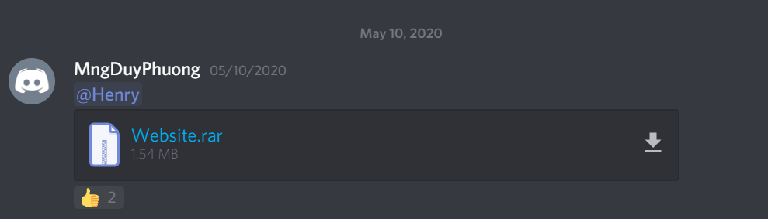

Re-located all the coding into specific folder. It helps to make the product clean, easy to maintain when we move to ‘Maintenance’ stage in a lifecycle of software development

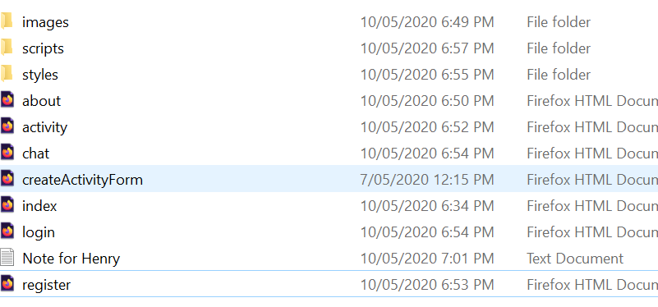

I created a small note for my fellow so he can understand what is going on, avoid the conflict in our project.

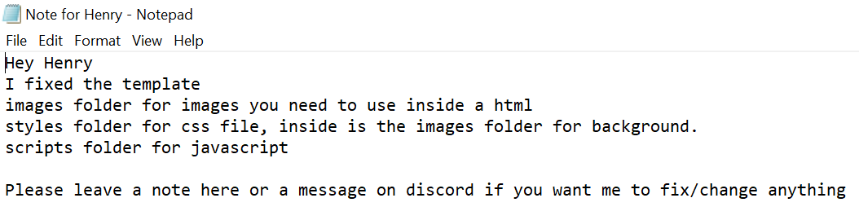

Index homepage with search function, its has been tested with TDD process.

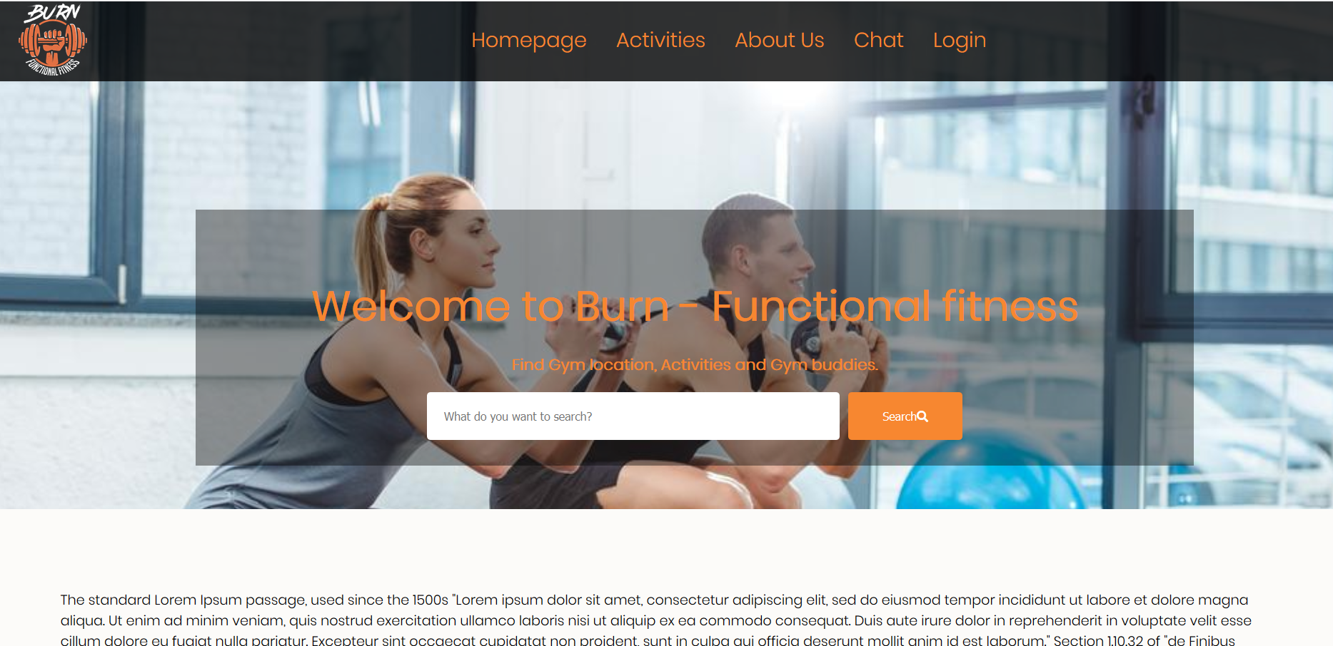

Other pages in our project.

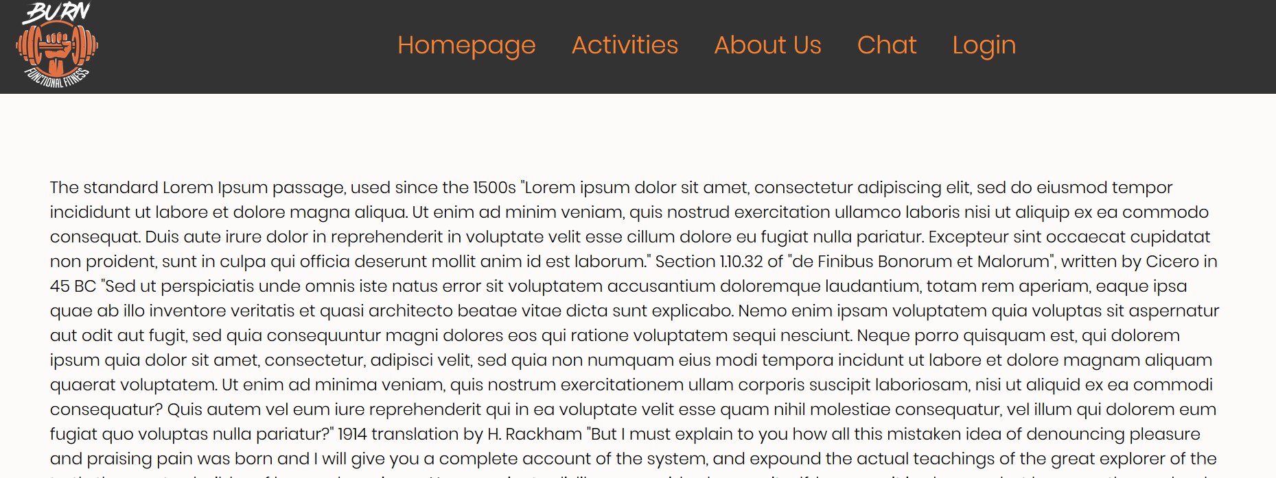

Code for template of project.

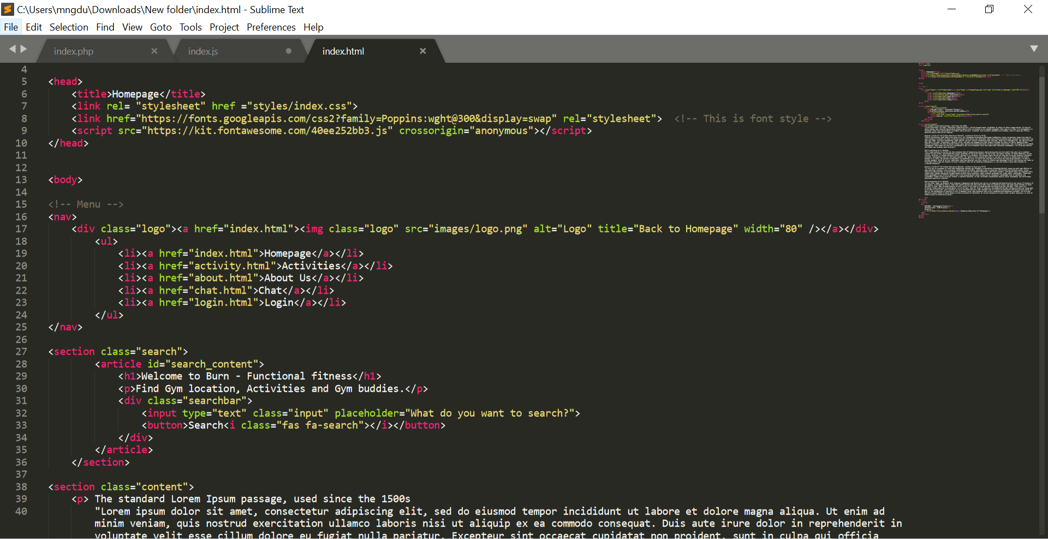

Mark up using CSS

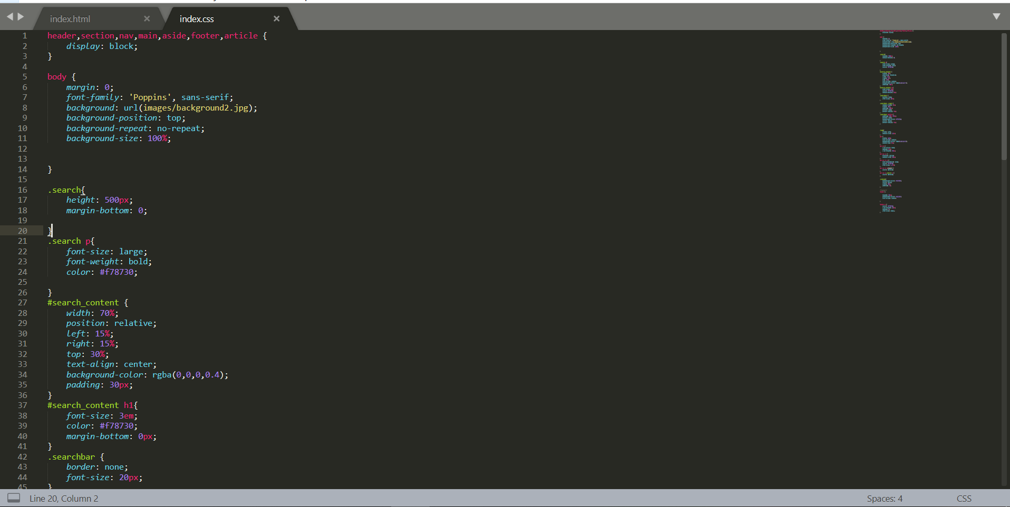

At this point, I asked my team leader to use GitHub which is a useful tool to avoid merge conflict and provide evidences for our report. However, my team leader and product owner refused, and we continued to use Discord as a flatform for merging code. As a team member, I can’t do anything further. We used Discord voice chat to discuss about this so I don’t have evidence to provide

**Week 9**

We continue with our second iteration.

**Week 10:**

We have the project presentation next week (26/5/2020) and I want to finish the project before the demonstration so we can deliver all the concepts of the product to our tutor, customers. I asked my team members to finish their coding this week so I can test them and move to the last iteration which is testing and finalise our product.

Henry sent me his works.

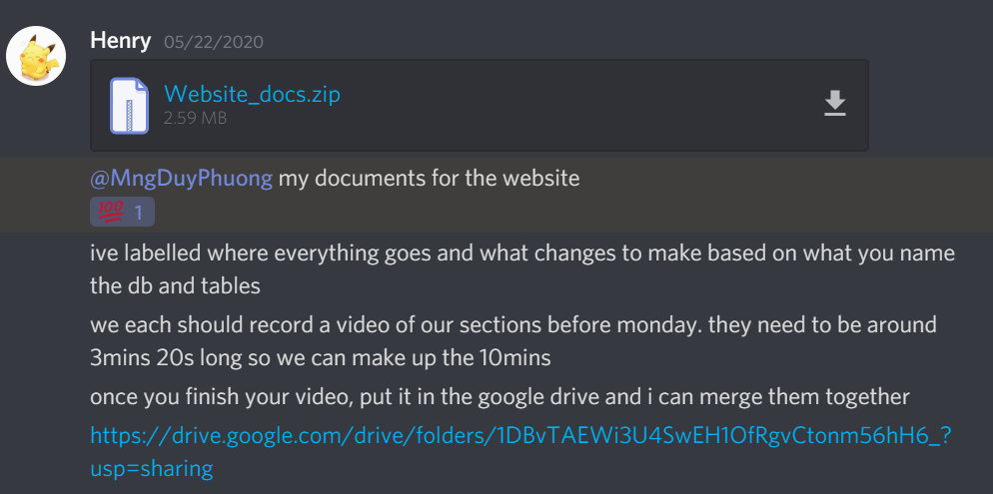

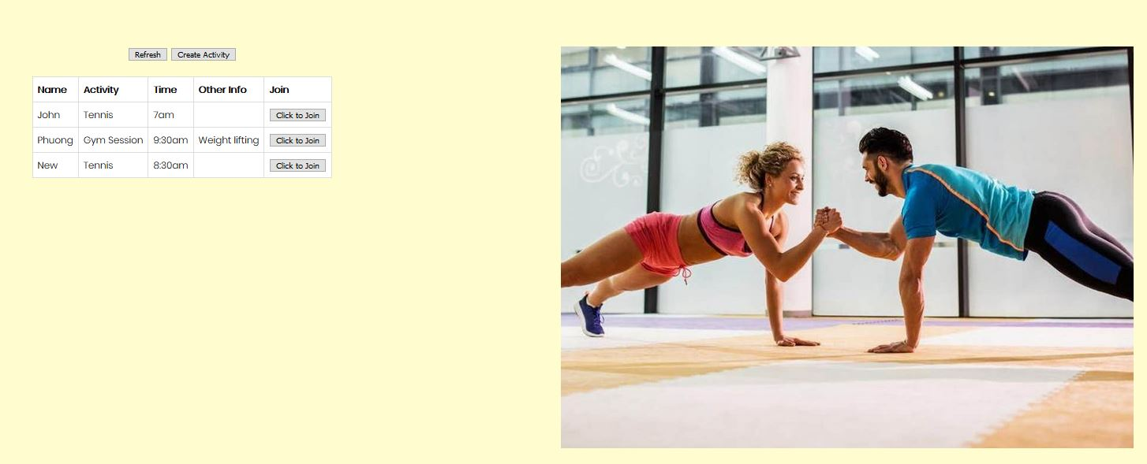

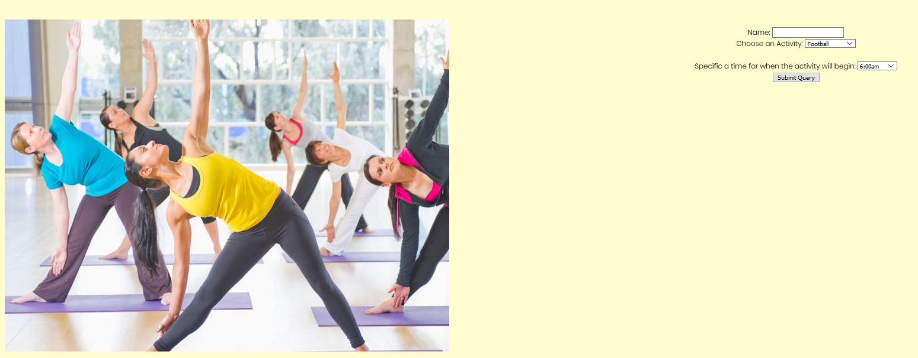

I think it can look better, so I changed the code and design by using CSS coding.

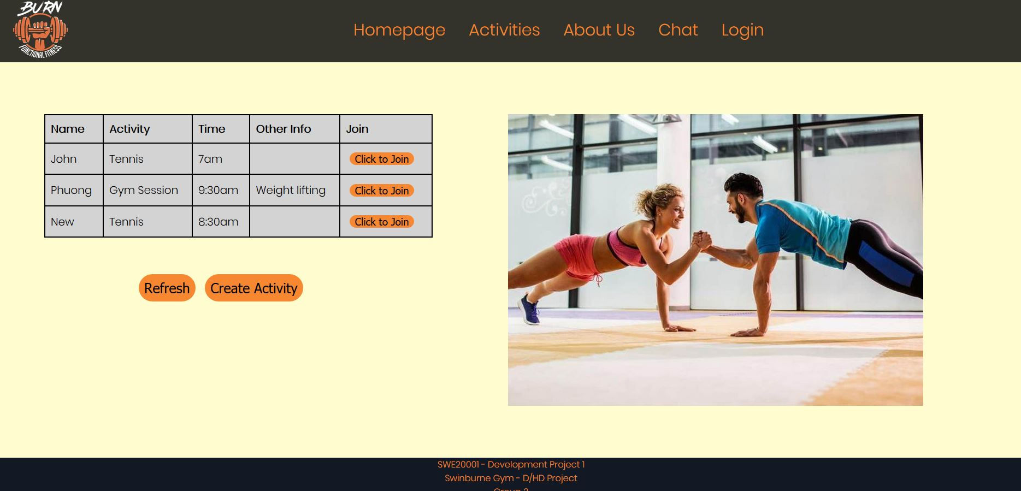

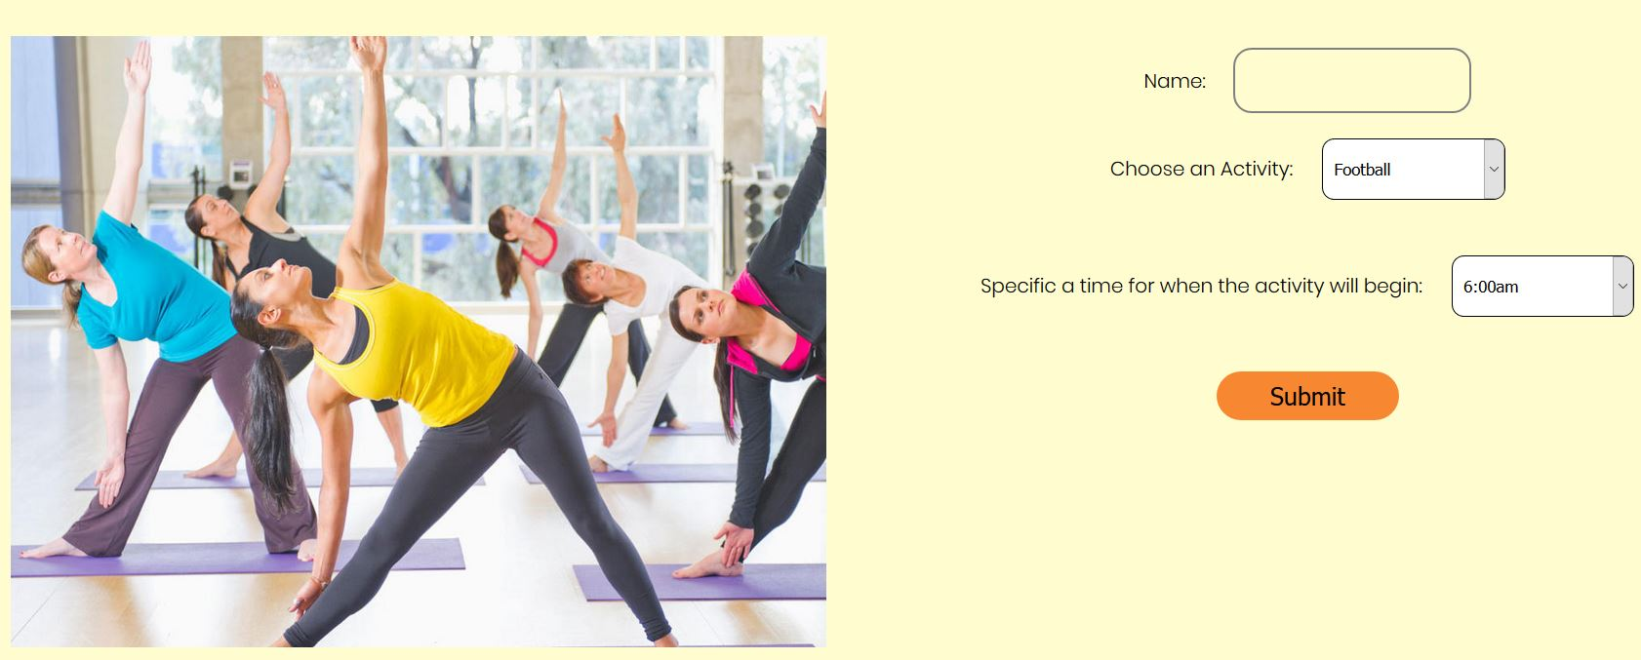

After finished the coding and designing, I finalised everything to make sure it’s working on another computer. I asked my team leader to check if it can run on his computer and asked my Product owner to check it meets his requirements or not. I showed them how to create database and how to run the product very details.

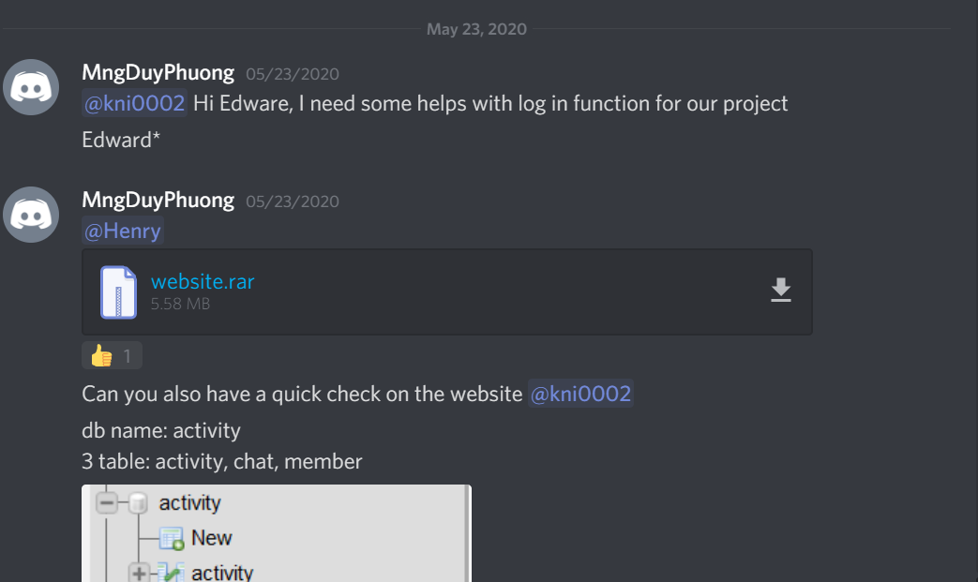

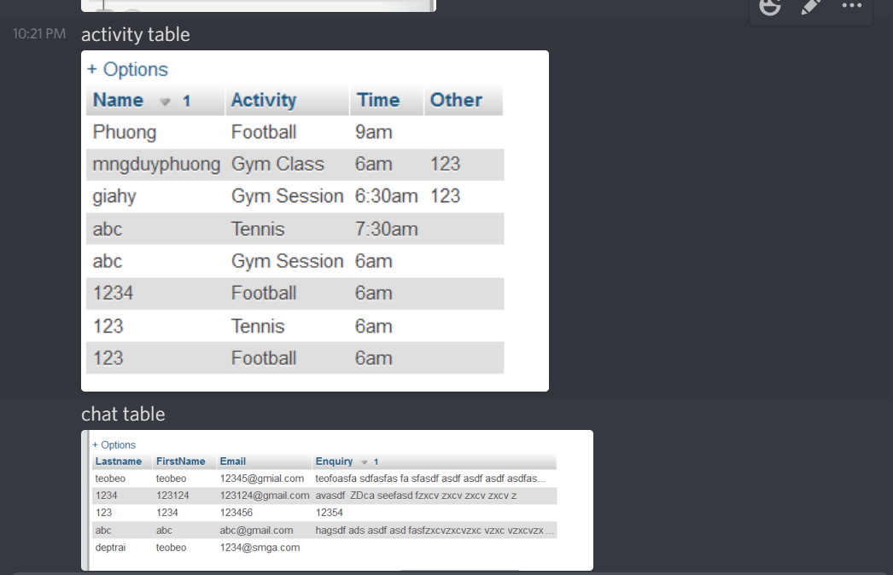

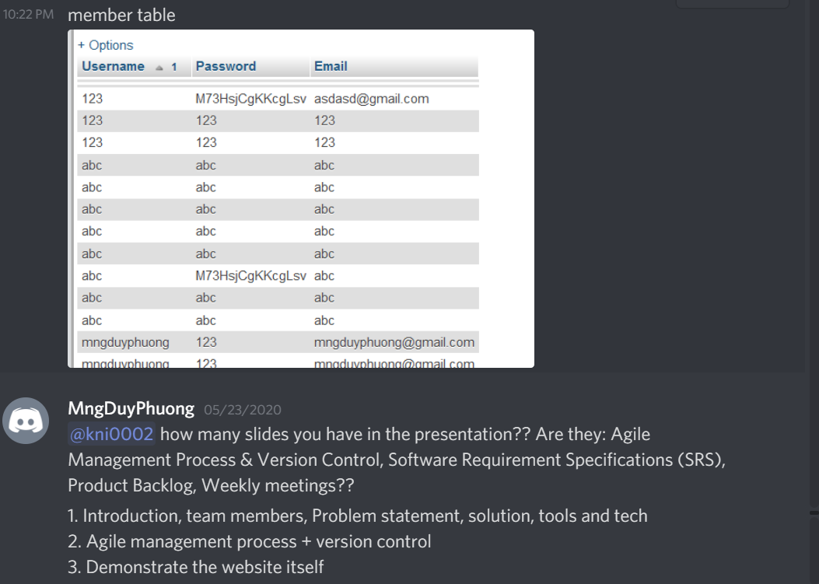

I asked ‘Product owner’ to check again his part in the presentation because it’s hard to communicate with him.

**Week 11:**

We did the presentation this week and I think that was a success because the product is working properly.

**Week 12:**

I did some research and found out our project missing some UnitTesting for the website. Since our group only has 3 members and our ‘Product Owner’ didn’t do much (only SRS which is 900 words) in the project so I asked him to help us on this part. I’m a bit tired and feel unfair.

No one replied me after that.

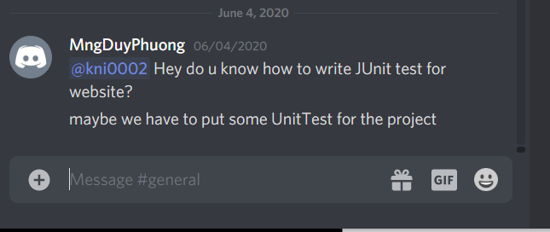

Discord channel: <https://discord.gg/XnjP8qe>

Trello board: <https://trello.com/invite/b/F5bzZg91/d1af2e036ca03440f7573e8060d91c02/d-hd-project>

Project vision document: <https://docs.google.com/document/d/1SUqZLmlUQg9dPGTYAZMrN3iHSsnp4V8JcTqsu7K69r4/edit?usp=sharing>

Presentation slides: <https://docs.google.com/presentation/d/1i5ihImtHBmKhtRiNGeZL9yjshx4ihXj_3MBA3UzlOVc/edit?usp=sharing>

Meeting minutes: <https://docs.google.com/document/d/1yOgk-_9Y_MMMPuQJSvEN6h7hmK9QzMBvAbpE_LMOm5M/edit?usp=sharing>

# Leadership, or facilitation, activity in at least one area of the project that relates strongly to the unit Learning Outcomes

As a developer of the group, I have a chance to practice and improve my leadership skills in lab tasks, project. I have the skills to organize an meeting with Meeting agenda, write meeting minutes and improve my communication skills which is very important because I’m an international student.

I also have a chance to practice the first Learning outcome which is “Lifecycle of software development project and describe the associated objectives of the different activities”. As the developer, I design the Iteration process, set the deadline for team members tasks, encourage, motivate and help them to finish their works.